**INTRODUCTION**

The role of interspecific competition in the evolutionary dynamics of species is thought to play a central role in trait evolution (e.g Schluter, 1994; Davies et.al., 2007). Expected outcomes from interspecific competition are either eventual exclusion of one species or reduction in niche overlap through negative selection on traits related to resource acquisition (Schoener, 1965). Lotka-Volterra models, when used to describe competition between multiple species with shared resources, yield patterns consistent with reduction in niche overlap such as limiting similarity or even species packing (MacArthur, 1970; MacArthur & Levins, 1967).Several studies have demonstrated these patterns using simple systems of pairwise interactions (for example, Taper, 1990; McGoey and Stitchcombe, 2009). By extension, the effect of competition on trait distributions of whole assemblages has been inferred by assuming that those traits relevant to competition should 1) diverge from each other and 2) become more evenly spread over evolutionary time (Kraft et al. 2008; Kraft & Ackerly 2010; Baraloto et al. 2012; Vergnon et.al. 2013). Patterns deviating from even trait spacing are often attributed to alternative ecological (facilitation or environmental filtering) or evolutionary (drift or lineage conservatism) processes.

This interpretation of patterns of trait spacing might not always be the consistent with eco-evolutionary trait dynamics within communities of multiple interacting species. For example, it is conceivable that more complex eco-evolutionary patterns might result when population dynamics are coupled with evolutionary trait dynamics. Moreover, the model results may be sensitive to the assumed mechanism that describes the niche overlap that then defines the strength of competition and subsequent selection pressure. For instance, a prevalent and useful class of trait-mediated interaction models assume that strength of competition between species is a function of relative difference between their functional traits, and that species always compete to some extent even if their traits are quite different. However, it may be more realistic to assume that species with large differences in traits no longer effectively compete. For example, mechanical fit between floral traits and proboscis lengths of nectar feeding bees could greatly limit the number of plant species that nectarivores can visit, thus creating stringent threshold to competition between different bee species (Garibaldi et al., 2015; Newman, Manning, & Anderson, 2014). Such thresholds will alter the number of interactions influencing average fitness of individuals and species trait evolution in a model and may strongly alter the eco-evolutionary dynamic.

To address such issues, we introduce more generality in describing the niche overlap between competitors using the trait-matching model (Barabás & D’Andrea, 2016; Nuismer & Harmon, 2015) and incorporate population dynamics using Lotka-Volterra based systems of equations. This not only enables us to allow the possiblity of applying thresholds to competition but such framework accounts for the feedback between population dynamics and trait evolution, and thus provides predictions about persistence of populations and communities, as well as coevolutionary trends in trait values across the species in a model community. Such Lotka-volterra based eco-evolutionary dynamics has already been used to assess the effect of intraspecific variation on community robustness and trait evolution of competing species (Barabasi and D’Andrea 2016). Additionally, this framework can also help track the changes in network structures with time, which may potentially contribute to the robustness of communities. Since traits govern the strength of competition between interacting species, changes in the interaction network can be estimated for the modeled system of evolving species as a function of changing trait values. Several measures of network structure, such as modularity and connectivity, have been linked to stability and resilience of communities in face of perturbations.

Thus, we employ an eco-evolutionary model that follows the one by Barabasi and D’Andrea (2016) with more generalized trait-matching model to analyze the impact of competition on community network structures and trait evolutionary patterns. Specifically, this model uses a Lotka-Volterra system-based equations that provide population growth rates i.e. an absolute fitness for different trait values in all populations and calculates changes in mean trait values using the breeder’s equation. Heritable intraspecific variation in these traits follows the infinitesimal model of quantitative genetics to determine the mechanism for trait propagation under selection pressure (Barabás & D’Andrea, 2016; Barton, Etheridge, & Véber, 2017). By systematically altering competition, intraspecific trait variance and demographic parameters within the model, we show that under certain circumstances, traits do not simply steadily diverge under competition yielding even trait spacing which is often interpreted as the outcome of competition. Instead, modular interaction networks can form that resemble those linked to greater stability.

**METHODS**

*Model description:*

The objective of this model is to describe trait and population dynamics of multiple competing species from same clade. We assume that in a community, populations of *n* species from one clade compete along a unidimensional axis of a single relevant trait; only the phenotypic value of interacting individuals determines the strength of the interaction, not the species’ identity. Propagation of the chosen trait is assumed to follow infinite loci model where multiple loci each give infinitesimally small contributions towards the trait value of an individual (Barabás & D’Andrea, 2016; Barton et al., 2017). This population genetics model predicts that the distribution of population’s trait values is normal, and its variance does not change in response to selection. Therefore, each population is assumed to have its phenotypes normally distributed with mean µi and variance, 𝜎i2, where *i* denotes distinct species.

Growth rate or fitness of an individual with trait value z, under Lokta-Volterra dynamics is a function of the individual’s intrinsic growth rate in absence of any competition subtracted from the collective effect of all intra- and interspecific competitive interactions of co-occurring individuals. Growth rate (or fitness) for an individual of species *i* with phenotype value z can be written as (Based on Barabás & D’Andrea, 2016):

$$w_{i}\left(z,t+1\right)=r_{i}-\frac{N_{i}(t)+\sum_{j≠i}{\int{α\left(z,z^{'},t\right)p_{j}(z^{'},t)dz'}}}{K_{i}}$$

Where, pi(z,t), the trait distribution for species i, is assumed to be Normal with mean µi and variance $σ_{i}^{2}$:

$$p_{i}(z,t)=\sqrt{\frac{1}{2πσ_{i}^{2}}} exp⁡(-\frac{{\left(z-µ_{i}\left(t\right)\right)}^{2}}{2σ_{i}^{2}})$$

ri is the intrinsic growth rate for species *i,* Ni is the population size of species i, Ki is the carrying capacity of species *i*, α, the coefficient of competition, is assumed to be a function of trait values of interacting individuals under the framework of trait-mediated interactions. The functional form of α is given as

$$α\left(z,z'\right)=e^{(-\frac{{\left(z-z^{'}\right)}^{2}}{ω^{2}})}$$

Where, z and z’ are the phenotypic values of interacting individuals and ω is the width of the competition which determines the rate of decrease in interaction strength as the trait difference becomes larger (Barabás & D’Andrea, 2016; Nuismer & Harmon, 2015). It is a symmetric function which implies that the effect of competition on both participants would be equal. It also represents a continuous function of difference between traits such that species will be continuously interacting until some point trait difference between any species becomes so large that species stop interacting. This interaction threshold can be modeled with a simple modification:

$$α\left(z,z'\right)=\left\{\begin{aligned}e^{\left(-\frac{{\left(z-z^{'}\right)}^{2}}{ω^{2}}\right), \left|z-z^{'}\right|≥t*} \\ 0, Otherwise\end{aligned}\right.$$

Where t* indicates a threshold difference between traits beyond which coefficient of competition is zero.

We can obtain a function for instantaneous growth rate for a population of each species by integrating trait-specific growth rates over the distribution of traits.

$$\frac{dN_{i}}{dt}=N_{i}r_{i}/K_{i}\int{(K_{i}-\sum_{\begin{aligned}j=1 \\ i≠j\end{aligned}}^{n}{N_{j}\int{α\left(z,z^{'}\right)p_{j}\left(z^{'}\right)dz'})dz}}$$

Additionally, the growth rate of an individual is also an absolute fitness of an individual. Based on this assumption we can combine the equation for the trait specific growth rates with the breeder’s equation, which provides the expression for response in mean traits to the selection differential on previous generation. As a result, the mean trait change for species i:

$${\frac{dµ_{i}}{dt}=\frac{-h_{i}^{2}r_{i}}{K_{i}}\sum_{\begin{aligned}j=1 \\ i≠j\end{aligned}}^{n}{N_{j}\int{\int{\left(z-µ_{i}\right)}}}α\left(z,z^{'}\right)p}_{i}(z)p_{j}(z^{'})dzdz'$$

Where, µi is the mean phenotype of the species *i,* and *hi* is the narrow sense heritability, which accounts for the genetic variation for additive genetic effects. Note that, under the infinitesimal quantitative genetic model, variance of population remains unchanged. Therefore, the expression for mean trait change alone provides the total evolutionary change in species under selection from competition, with variance 𝜎i2.

*Parameters of interest:*

We focused on three parameters of this model that influence the trait dynamics of a given species: two of them, ω (width of competition) and t* (trait difference threshold to competition) describe the trait-matching model between competing individuals and the third parameter, $σ_{i}^{2}$, intraspecific trait variance, describes species specific trait variation. Based on the models above we can deduce that i) higher values of ω indicate stronger competition between individuals with given trait values, i.e. for higher values of ω, strength of competition decreases slower with trait difference, thus, imposing stronger selection pressure on competitors. Lower ω values indicate stronger adherence to the trait-matching mechanism. ii) Threshold values, t*, dictate whether individuals compete or not based on their trait values. At the species level, t* signifies a neighborhood of competitors for a given species. iii) Intraspecific trait variation for a given species, $σ_{i}^{2}$, indicates the species’ response to selection pressure. Higher trait variance will lower the rate mean trait change for a given species. While the individual influence of these parameters on species’ trait evolution can be easily deduced, their collective impact on community level emergent properties is difficult to assess. Thus, we simulated population and trait dynamics of varying assemblages of competing species and assessed the influence of the parameters on community level patterns.

*Simulating population and trait dynamics:*

For each initial assemblage of 20 or 50 species, we generated 60 distinct combinations of parameters by choosing following values for three parameters:1) Threshold to competition: either 5,7,10 or no threshold. 2)Intraspecific variability: For each species, the standard deviation for the trait distribution was chosen from one of the three uniform distributions - low: [0.5,1.5], high: [2.5,3.5], wide: [0.5,3.5]. 3)Width of competition: either 0.05, 0.1, 0.25,0.5 or 1. Higher value signify a stronger negative impact of competition.

We incorporated these parameter combinations with 100 different sets of initial conditions (for initial population size, carrying capacity and intrinsic growth rates). Initial population sizes for species were chosen from folded normal distribution with mean 1000 and standard deviation 500. Carrying capacities were set to be double of initial population sizes for respective species. Intrinsic growth rates were chosen from a folded normal distribution with mean 0 and standard deviation 0.5. Initial trait means are randomly sampled from a Normal distribution with mean 0 and standard deviation 5. Narrow sense heritability was fixed at 0.5. Values of trait means, and variabilities were chosen relative to the smallest value of the threshold to competition (5, in this case). In this way, we could get a large variety of initial networks structures.

Each simulation was run for 50000-time units. During the simulation, species whose populations went below zero were removed and labelled as ‘extinct’. Population and trait dynamics following the equations above were simulated in R. We ran simulations with assemblages of 20 species and 50 species.

*Response variables.*

During the simulation, at 50 intermediate time points, connectance, maximum modularity and a trait spacing parameter, Mean Nearest Neighbor Distance (MNND) were calculated for existing set of species.

In order to calculate connectance and maximum modularity, interaction networks were constructed using interaction strengths calculated from the function α at multiple time points during the simulation. Interaction strength between two species was calculated approximately using the mean trait values rather than the complete trait distributions. Connectance is defined as the fraction of actual links in relation to the total number of possible links in a network. Maximum modularity was calculated by using fastgreedy algorithm (Clauset, Newman, & Moore, 2004). Mean Nearest Neighborhood Distance (MNND) was calculated as follows:

MNND= $\frac{\left(n-1\right)*\sum{nnd}}{range*n}$ (Based on Findley, 1976).

**RESULTS**

**Sample outcome of a simulation:** 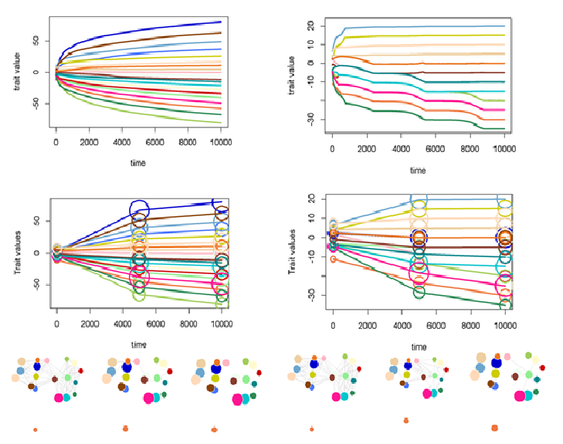

Fig.1: *Sample outcome of a simulation with (right panel) and without (left panel) using thresholds to competition. Top figures show trait evolution of 20 competing species. Middle and bottom figures represent three timepoints in the simulation (initial, middle and end). Middle figures represent the association between trait changes and population size (circle sizes) changes at three time points.* *Bottom images show the changes in network structure through time.*

In a typical simulation run, traits diverge over evolutionary time, with rates of change being fast initially and then slowing (Fig.1). However, the addition of a threshold to competition can drastically change the evolutionary trends of species (Fig.1). In the simulation without any threshold (left panel, bottom figure), the traits diverge more uniformly and the differences in mean trait values of species gradually become more even over time. However, when thresholds are included in the simulation, the rates of divergences between species become highly irregular (right panel, bottom figure), leading to instances where traits of two or more species converge towards each other. Such ‘clustering’ of traits emerges for multiple sets of species. Consequently, modular interaction network structures can emerge out of arbitrary initial assemblages of traits (right panel, middle figure), even though traits generally seem to diverge among species. This persistence of groups or pair of similar species occurs even without any stochastic variation. These modules seem to persist for larger periods of time, however; they eventually tend to break apart as variance in community trait values widens, leading to a more evenly dispersed trait distribution.

**Network dynamics:**

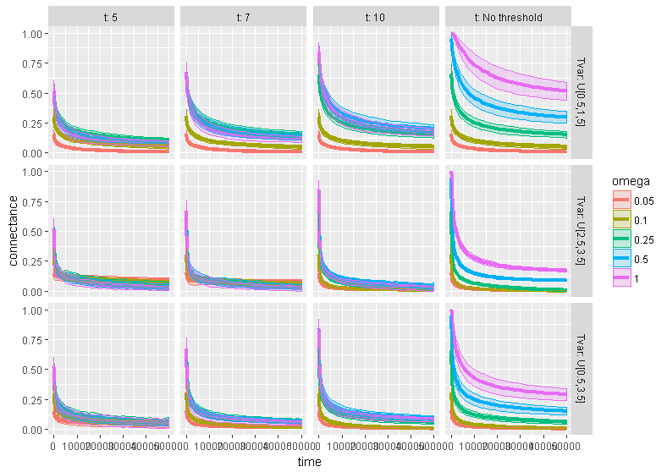

Fig. 2: *Change in connectance with time. Each panel represents a combination of intraspecific variation (top) and threshold for competition (side). In each plot, different trajectories represent different omegas (width of competition). The variation in each trajectory is the standard deviation in means taken from 100 simulation in each panel.*

The combination of parameter values highly influences the aggregate trends in network structures with time (Fig.2 and 3).

Thresholds (Fig.2 columns) and intraspecific variation (Fig.2 rows) have little effect on overall trends in connectance of evolving interaction networks. Connectance decreases over time in all scenarios (Fig.2). When thresholds are absent (Fig. rightmost column panels), connectance values decrease slowest. They decrease faster as thresholds get narrower, and for lower values of ω (Fig 2, first, second and third column panels). Different amounts of intraspecific variation do not seem to strongly alter the dynamics of connectance values.

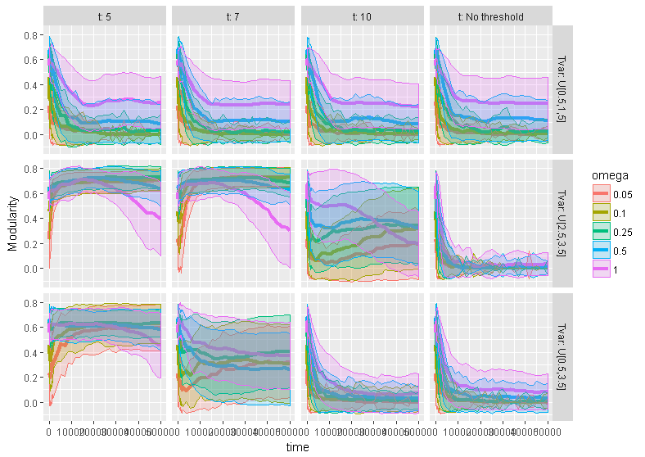

Fig.3 *Change in modularity with time. Each panel represents a combination of intraspecific variation (top) and threshold for competition (bottom). In each plot, different trajectories represent different omega (width of competition). The variation in each trajectory is the standard deviation in means.*

Thresholds, intraspecific variation and ω interact to create very diverse trends in modularity across scenarios (Fig.3). In the absence of thresholds, modularity always declines to a stable value within first 1000-2000 generations (Fig.3, rightmost column panels). This decline is particularly fast when intraspecific variation was high in some or all species, and the final modularity almost reaches zero for all values of ω (Fig 3, right column bottom two panels). When intraspecific variation is low, the decline is slower and the final equilibrium modularity values are non zero and positively related to ω (Fig 3j). Interestingly, that same pattern is in the presence of low intraspecific variation under all threshold scenarios (Fig 3a,d,h,l).

A very different trend in modularity is observed when intraspecific variation is high and thresholds are narrower (t =5 and 7) (Fig 3, two leftmost columns and two bottom rows). In these cases, modularity initially increases rapidly and gradually decreases with time. When ω is lowest, this initial increase is steepest, reaching a relatively high modularity that remains stable until the end of the simulation. When ω is greater, this initial increase is modest because the initial modularity is already high to begin with, and modularity starts to decline from it’s maximum by the simulation’s end. For the highest threshold value (t = 10), the dynamics are an amalgam of that the two different patterns described above. An initial decrease in modularity is followed by a modest increase, that then a final decrease. The value of ω is positively related to the speed of this dynamic; higher ω causes the initial decline and the eventual decline to happen sooner.

**Trait dynamics:**

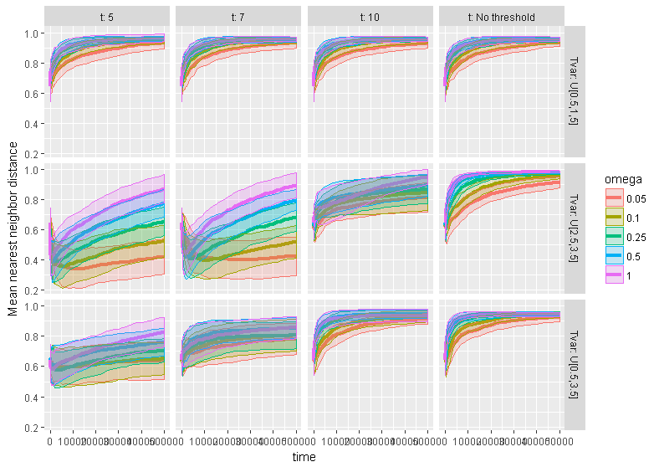

Fig.4: *Change in mean nearest neighbor distance (MNND) with time. Each panel represents a combination of intraspecific variation (top) and threshold for competition (bottom). In each plot, different trajectories represent different omega (width of competition). The variation in each trajectory is the standard deviation in means.*

The trait spacing metric, MNND, is also strongly influenced by different combinations of parameter values (Fig.4). For the simulations with no threshold (Fig.4, rightmost column panels), MNND values rise sharply initially and reach the asymptote at 1. Higher values of ω accelerate the dynamics where MNNDs reach 1 quicker than those with lower ω values. High intraspecific variation for all the species (Fig.4, rightmost column and second row) cause this increasing trend to slow and an asymptote is reached much later.

A very contrasting trend is observed when the intraspecific variation values are high and the thresholds are narrow (t=5 and t=7) (Fig.4, two leftmost columns and two bottom rows). MNND values show sharp decrease compared to initial values and then gradually increase towards 1. Higher ω values accelerate these trends where the fall and the rise in MNNDs are much quicker.

The highest possible value of MNND is 1 and it indicates perfectly even spacing for trait means. In all cases MNND values eventually tend towards 1 (Fig. 4). However, significant deviations from 1 can persist for long periods of time, especially when intraspecific variation is high for the populations and threshold to competition is relatively small. And ω values do not necessarily affect the qualitative nature of trends but contribute strongly to accelerate the trends. Simulations with low values of intraspecific variation essentially follow the trend of simulations with no threshold. The highest threshold (t=10) shows intermediate trends where simulations with low or high range of intraspecific variation values mimic the trends of those with no threshold, while high intraspecific variation causes the trends similar to those with narrower thresholds.

**Discussion:**

**Our results show that simple competitive eco-evolutionary process can exhibit evolution of highly diverse network structures as well as trait distribution patterns which show variability in their persistence through time. All three of the parameters we varied, levels of intraspecific variation, threshold to competition and width of competition, interact together to strongly influence the dynamics**.

The results can be explained using the basic premise of the model we have used, in that, with time, links within a competitive network will start breaking, albeit at different rates as a result of either extinction or trait divergence (certainly new links can also potentially emerge), we can view the patterns of network and trait dynamic from figures 2,3 and 4 in the context of which connections or links break first and which ones persist longer.

Trends in connectance values show very consistent decreasing patterns and depend very little on parameter values. This is not very surprising since connectance will decrease as long as interactions become weak or disappear completely. This will happen since our model indicates that traits will diverge, and competition will reduce with time. When thresholds are absent (Fig.2 rightmost column panels), connectance values decrease slowest. They decrease faster as thresholds get narrower, and for lower values of ω (Fig 2, first, second and third column panels), because smaller differences in trait values are needed to break links between species in these scenarios. This generalized outcome agrees with empirical networks as well as other theoretical analyses, which show prevalence of low connectance ((Allesina & Pascual, 2008; Allesina & Tang, 2011; DeAngelis, 1975; Rejmánek M. & Stary, 1979) in communities.

Trends in changes of modularity show strong dependence on parameter combinations. Value of modularity is determined by the presences of clusters of species which show stronger or more interactions within a cluster compared to the ones between clusters. This can be easily demonstrated in our framework where, we can position all the species along a single trait axis according to their mean trait. Trait-matching rule dictates that interactions will be stronger between a pair of species if they are positioned closer on a trait axis. Given that species’ traits diverge due to competition, if the rates of divergences are more uniform across species, the links will break (or weaken) more uniformly along a trait axis, leading to less modular structure. This would explain the loss of modularity with time for the cases of no threshold where rates of divergences are more uniform.

In contrast, when competing species have high range of trait variation and exhibit stringent thresholds to competition, their rates of divergence would be weaker and the breaks in links will be dictated more by low thresholds, leading to non-uniform breaks and thus, more modular structures.

Trends in MNNDs can be explained similarly. The highest possible value of MNND is 1 and it indicates perfectly even spacing for trait means. In all cases MNND values eventually tend to change towards 1 (Fig. 4). However, significant deviations from 1 can persist for long periods of time, especially when intraspecific variation is high for the populations and threshold to competition is relatively smaller. And ω values don’t necessarily affect the qualitative nature of trends but contribute strongly to accelerate the trends.

In general, our results indicate that at any given time, variety of trait and network patterns can be observed simply as a result of competitive interactions. Additionally, species typically exhibit considerable intraspecific trait variation and the cases of nectar feeding birds or insects can present stringent conditions for mechanical fit leading to low thresholds to competition (Moré et al., 2012; Newman et al., 2014). Thus, the conditions that lead to highly clumped trait distribution or modular structures in our model are definitely plausible. Many hypotheses regarding the effects of competition between co-occuring species of the same clade expect overdispersion of traits (refs) or destabilizing effects on a network dynamics (Refs). Thus, our results suggest caution in testing these hypotheses and further analyses of relevant parameters in a system.

One important theoretical implication of our results is regarding the stability and complexity problem of community ecology. Using principles of network theory, it is well supported that in antagonistic as well as mutualistic networks, weak interactions and high modularity render communities stable towards perturbations (Allesina & Tang, 2011; May, 1971, 1973). However, these analyses typically examine the behavior of a system near equilibrium. It is still unclear how these stabilizing modular patterns can emerge out of arbitrary initial assemblies. Our results suggest that it is possible for modular patterns to emerge and persist from simple competitive eco-evolutionary dynamics.

One caveat behind the usefulness of the model is that the population dynamics and even the trait dynamics of species show great variation and although not formally analyzed, are quite sensitive to initial conditions. Thus, it becomes crucial to focus on the outcomes or metrics that are not species-specific but rather related to aggregate or emergent community properties. Despite considerate variation in demographic properties of species, we observed quite consistent trends in community-level patterns. This indicates the usefulness of such class of models and that they provide robust framework to which additional specific mechanisms can be incorporated.

Clearly, the model we used is simplistic in nature and makes assumptions about population genetic processes of trait propagations, relationship between traits and interaction strengths and does not incorporate stochastic demographic processes. Robustness of the basic model to the population genetic model used is analyzed (Barabás & D’Andrea, 2016). I will write more about this.

The framework is readily useful to address the questions regarding community response to disturbances or the invasions. More generally, a fitness landscape can be mapped for a constituent or an incipient species in a given community on a trait space occupied by other species, similar to building adaptive landscapes over environmental axes. It is interesting to see if there are persistent hot/cold spots of selection pressure over trait space for a given species and whether they depend on species’ characteristics such as rare vs. dominant species, or degree of the species within a network.

References:

Allesina, S., & Pascual, M. (2008). Network structure, predator - Prey modules, and stability in large food webs. *Theoretical Ecology*, *1*(1), 55–64. https://doi.org/10.1007/s12080-007-0007-8

Barabás, G., & D’Andrea, R. (2016). The effect of intraspecific variation and heritability on community pattern and robustness. *Ecology Letters*, *19*(8), 977–986. https://doi.org/10.1111/ele.12636

Barton, N. H., Etheridge, A. M., & Véber, A. (2017). The infinitesimal model: Definition, derivation, and implications. *Theoretical Population Biology*, *118*, 50–73. https://doi.org/10.1016/j.tpb.2017.06.001

Bolnick, D. I., Amarasekare, P., Araujo, M. S., Burger, R., Levine, J. M., Novak, M., … Vasseur, D. a. (2011). Why intraspecific trait variation matters in community ecology. *Trends in Ecology and Evolution*, *26*(4), 183–192. https://doi.org/10.1016/j.tree.2011.01.009

Clauset, A., Newman, M. E. J., & Moore, C. (2004). Finding community structure in very large networks. *Physical Review E - Statistical Physics, Plasmas, Fluids, and Related Interdisciplinary Topics*, *70*(6), 6. https://doi.org/10.1103/PhysRevE.70.066111

Connell, J. H. (1980). Diversity and the Coevolution of Competitors , or the Ghost of Competition Past. *Oikos*, *35*(2), 131–138.

DeAngelis, D. L. (1975). Stability and Connectance in Food Web Models. *Ecology*, *56*(1), 238–243.

Eklöf, A., Jacob, U., Kopp, J., Bosch, J., Castro-Urgal, R., Chacoff, N. P., … Allesina, S. (2013). The dimensionality of ecological networks. *Ecology Letters*, *16*(5), 577–583. https://doi.org/10.1111/ele.12081

Garibaldi, L. A., Bartomeus, I., Bommarco, R., Klein, A. M., Cunningham, S. A., Aizen, M. A., … Woyciechowski, M. (2015). Trait matching of flower visitors and crops predicts fruit set better than trait diversity. *Journal of Applied Ecology*, *52*(6), 1436–1444. https://doi.org/10.1111/1365-2664.12530

Jonathan Davies, T., Meiri, S., Barraclough, T. G., & Gittleman, J. L. (2007). Species co-existence and character divergence across carnivores. *Ecology Letters*, *10*(2), 146–152. https://doi.org/10.1111/j.1461-0248.2006.01005.x

MacArthur, R. (1970). Species packing and competitive equilibrium for many species. *Theoretical Population Biology*, *1*(1), 1–11. https://doi.org/10.1016/0040-5809(70)90039-0

MacArthur, R., & Levins, R. (1967). The Limiting Similarity , Convergence , and Divergence of Coexisting Species Author ( s ): Robert Macarthur and Richard Levins Source : The American Naturalist , Vol . 101 , No . 921 ( Sep . - Oct ., 1967 ), pp . 377-385 Published by : The University of C. *The American Naturalist*, *101*(921), 377–385.

May, R. M. (1972). Will a large complex system be stable? *Nature*, *238*, 413–414. https://doi.org/10.1038/238413a0

May, R. M. (1971). Stability in multispecies community models. *Mathematical Biosciences*, *12*(1–2), 59–79. https://doi.org/10.1016/0025-5564(71)90074-5

Mccann, K. S. (2000). The diversity stability debate. *Nature*, *405*(May), 228–233. https://doi.org/10.1007/978-1-4615-9968-5_10

McGoey, B. V., & Stinchcombe, J. R. (2009). Interspecific competition alters natural selection on shade avoidance phenotypes in Impatiens capensis. *New Phytologist*, *183*(3), 880–891. https://doi.org/10.1111/j.1469-8137.2009.02934.x

Moré, M., Amorim, F. W., Benitez-Vieyra, S., Medina, A. M., Sazima, M., & Cocucci, A. A. (2012). Armament imbalances: Match and mismatch in plant-pollinator traits of highly specialized long-spurred orchids. *PLoS ONE*, *7*(7). https://doi.org/10.1371/journal.pone.0041878

Newman, E., Manning, J., & Anderson, B. (2014). Matching floral and pollinator traits through guild convergence and pollinator ecotype formation. *Annals of Botany*, *113*(2), 373–384. https://doi.org/10.1093/aob/mct203

Newman, E., Manning, J., & Anderson, B. (2014). Matching floral and pollinator traits through guild convergence and pollinator ecotype formation. *Annals of Botany*, *113*(2), 373–384. https://doi.org/10.1093/aob/mct203

Nosil, P., & Crespi, B. J. (2006). Experimental evidence that predation promotes divergence in adaptive radiation. *Proceedings of the National Academy of Sciences*, *103*(24), 9090–9095. https://doi.org/10.1073/pnas.0601575103

Nuismer, S. L., & Harmon, L. J. (2015). Predicting rates of interspecific interaction from phylogenetic trees. *Ecology Letters*, *18*(1), 17–27. https://doi.org/10.1111/ele.12384

Rejmánek M., & Stary, P. (1979). Connectance in real biotic communities and critical values for stability of model ecosystems. *Nature*, *280*(July), 311–313.

Schoener, T. W. (2006). The Evolution of Bill Size Differences Among Sympatric Congeneric Species of Birds. *Evolution*, *19*(2), 189. https://doi.org/10.2307/2406374

Smith, R. A., & Rausher, M. D. (2008). Selection for character displacement is constrained by the genetic architecture of floral traits in the ivyleaf morning glory. *Evolution*, *62*(11), 2829–2841. https://doi.org/10.1111/j.1558-5646.2008.00494.x

Stouffer, D. B., Rezende, E. L., & Amaral, L. A. N. (2011). The role of body mass in diet contiguity and food-web structure. *Journal of Animal Ecology*, *80*(3), 632–639. https://doi.org/10.1111/j.1365-2656.2011.01812.x

Terhorst, C. P. (2011). Experimental evolution of protozoan traits in response to interspecific competition. *Journal of Evolutionary Biology*, *24*(1), 36–46. https://doi.org/10.1111/j.1420-9101.2010.02140.x

Weber, M. G., Wagner, C. E., Best, R. J., Harmon, L. J., & Matthews, B. (2017). Evolution in a Community Context: On Integrating Ecological Interactions and Macroevolution. *Trends in Ecology and Evolution*, *32*(4), 291–304. https://doi.org/10.1016/j.tree.2017.01.003

Zook, A. E., Eklof, A., Jacob, U., & Allesina, S. (2011). Food webs: Ordering species according to body size yields high degree of intervality. *Journal of Theoretical Biology*, *271*(1), 106–113. https://doi.org/10.1016/j.jtbi.2010.11.045

Unused text:

We explored how networks with large assemblage of competing species change with eco-evolutionary dynamic and which conditions promote and maintain certain stabilizing structures. Additionally, we also explored how trait distribution of species in community changes as species coevolve.

However, modularity values measure the presence of clusters within a community where number of links within a cluster is higher (or the links have higher weights) than the links between clusters. Thus, species closer to each other on a trait axis would have more and stronger links between them. After subjected to competitive dynamics, if the links between species are breaking at uniform intervals, fewer modular structures would emerge since there will be higher proportion of links between clusters compared to the case where links are disappearing in a non-uniform manner.

Basic premise of the model used here informs that negative selection pressures imposed by competition should result either in local extinctions and/or species evolving their traits to reduce the competition and thus eventually escaping the competition altogether (since no explicit upper or lower bounds are imposed on trait values). However, this “eventuality” can vary considerably and would depend on relevant parameters in the dynamic, as our results suggest. And before this eventuality of species escaping competition altogether, highly persistent network structure and trait spacing patterns can emerge, which are explicitly the results of competitive dynamics.

The case of decreasing connectance is simple. Extinctions can reduce the number of maximum possible number of links in a network thus possibly inflating the connectance value, but extinctions will be associated with further loss of interactions as well thus keeping the trend of decreasing connectance values.

References.